FALL 2017 PARENT MEETING
Hair:
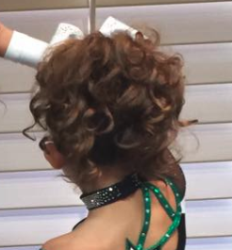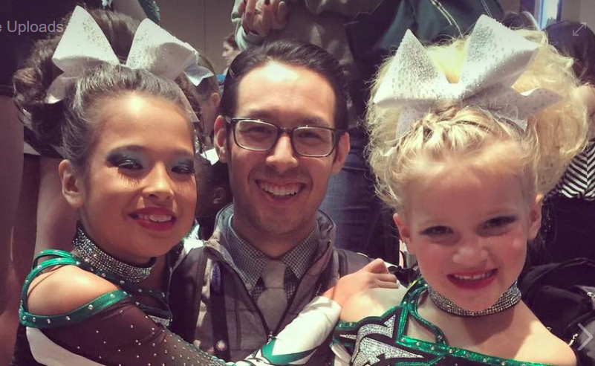
Make-up:
- Purchase kits onsite at Showcase (or order if sold out)
- https://www.youtube.com/watch?v=XsXlfJdF-FY
- 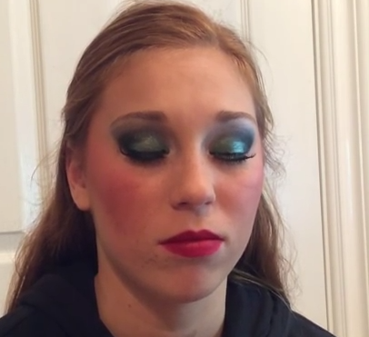

Oct 16-19th: SPIRIT WEEK
  - If you are in the gym for a team practice or a class, be sure to dress up and have fun this week!
  - Oct 16th: Crazy Hair Day
  - Oct 17th: Crazy Sock Day
  - Oct 18th: On Wednesdays we wear Pink – Breast Cancer Awareness
  - Oct 19th: Disney Day
Oct 30th: Trunk or Treat – we need sign-ups!
Attendance and absence fees – absence fees are now being applied to your account if you miss a practice. Any absences two weeks out of a competition could mean being replaced.
Prep teams – practices started this week, currently at 69 in enrollments! Thank you for all your help in sharing the word!
Saturday, Nov 4th: Nfinity Stunt Clinic (proceeds help Nfinity defend their World Title!)
- Want to win free admission to the Nfinity clinic? To be entered in the drawing, all you have to do is leave a positive review on social media! We are looking for more current reviews on FB, Yelp, & Google.
Uniform Status
Mon, Nov 6th Warm-up Jacket fitting, Backpack and Shoe orders due
Refresh Google Calendar for updated practices/competitions

