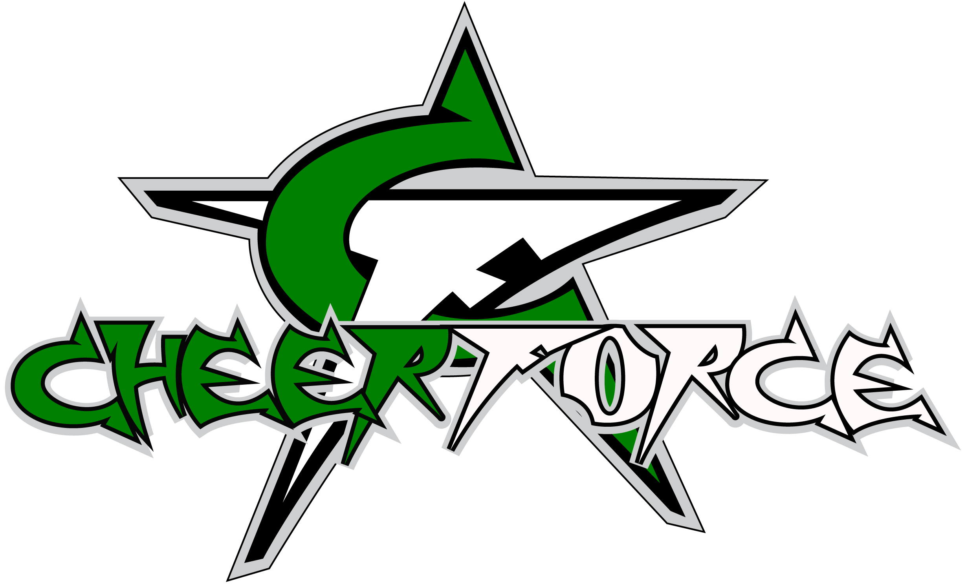
LIABILITY RELEASE AND WAIVER FORM
GIVE A COPY OF THIS FORM TO EVERY PARTICIPANT

Every participant must have completed and signed release and returned to CheerForce Central Valley.

Minor’s Name:____________________________________________ D.O.B:________/________/_________
Parent or Legal Guardian Name:____________________________________________________________
Address_______________________________________________________________________________________
City:_________________________________ State:________________________ Zip:_____________________
Home Phone: ( )_____________________ Cell Phone: ( )________________________________
Email Address:_______________________________________________________________________________

Liability Release: For good and valuable consideration, the receipt and sufficiency of which are herby acknowledged, I ____________________________________, as parent or legal guardian of ___________________________________________, a minor (hereinafter “minor”), hereby grant the permission necessary to allow the above named to participate at CheerForce Central Valley. I, in my own behalf and on behalf of minor, further agree to release and hold CheerForce Central Valley (CFCV), the affiliates of CheerForce Central Valley their affiliates (hereinafter collectively “Releases”) from any and all liability whether caused by negligence of the Releases or otherwise for any claim, judgment, loss, liability, cost and expenses (including, without limitations, attorney’s fees and costs) arising out of or connected with the event, including any claim arising out of or connected with any illness or injury (minimal, serious, catastrophic and/or fatal) that minor may incur or sustain during the event, all activities associated with CFCV and while traveling to and from the event whether or not the event took place. I further expressly agree to indemnify and hold harmless Releasees and Releasees’ heirs, successors, assigns, executors and administrators against loss from any further claims, demands or actions that may subsequently be brought by the minor or by any other person on the account of damages of any character resulting to minor in any way from the foregoing activities. I further agree to reimburse and to make good to Releasees’ any loss or costs Releasees may have to pay a result of such any action, claim or demand. I, in my own behalf and on behalf of minor, here by warrant that I have read this Liability Release in it’s entirety and fully understand it’s contents. I, in my own behalf and on behalf of minor, am aware that this Liability Release Form releases Releasees’ from liability and contains an acknowledgement of my voluntary and knowing assumption of the risk or injury or illness. I, in my own behalf and on behalf of minor, further acknowledge that nothing in this Liability Release constitutes a guarantee that the even will occur. I, in my own behalf and on behalf of minor, have signed this document of my own free will.

Signature of Parent or Legal Guardian:
X_____________________________________________________________ Date: ______/______/________

